M3 – Evaluate the Performance of a Computer System

To evaluate the performance of the computer (benchmark it), I used PerformanceTest 8.0, a program that benchmarks a PC by running tests on various components.

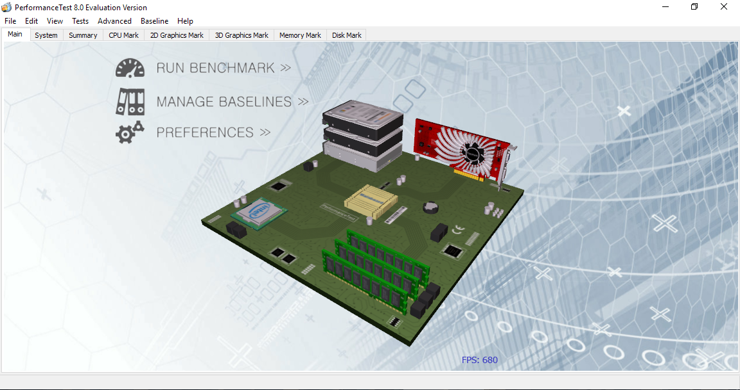

PerformanceTest 8.0, showing a 3D model of all the components it can test, including CPU, GPU, RAM, and drives.

The tests that the program runs include:  
- CPU benchmarking, with integer and floating point calculations, sorting, ecryption and threading  
- GPU benchmarking, with 2D and 3D rendering in several different graphics engines  
- Drive read/write speeds, and error rates  
- RAM read/write speeds, and error rates  
- System responsiveness, by testing windows form inputs (buttons, check boxes, etc) and rendering of text and images

PerformanceTest gave the computer an overall score of 1077 (a composite average of the other results). This is in comparison to four other setups.

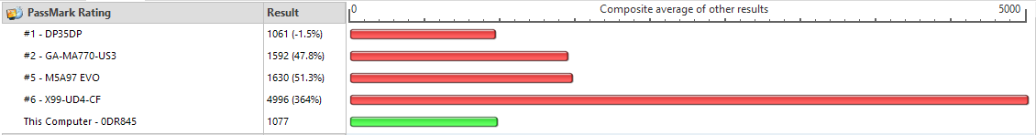

It also gave results for each component in its own category of tests.

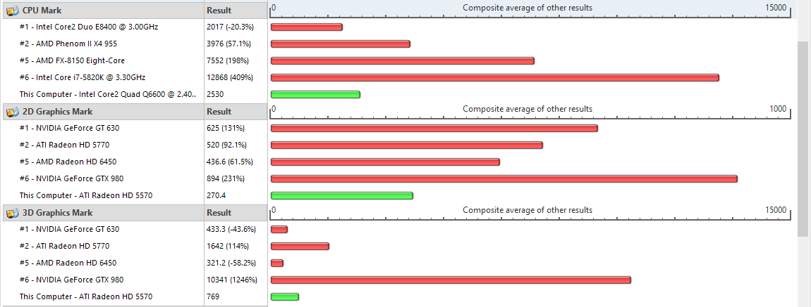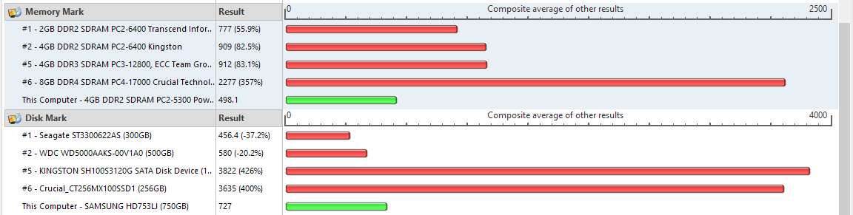

The default comparisons are against high-end components, which is why this PC usually had the lowest scores.

However, in comparison to standard desktop machines for a work environment, this PC is very powerful, making it ideal for multi-tasking.